


SAVEETHA SCHOOL OF ENGINEERING

SAVEETHA INSTITUTE OF MEDICAL AND TECHNICAL SCIENCES

COMPUTER SCIENCE AND ENGINEERING PROGRAMME

LAB MANUAL CSA1305

THEORY OF COMPUTATION

COMPUTER SCIENCE AND ENGINEERING PROGRAMME

LIST OF EXPERIMENTS

- To write a C program to check whether a string belongs to the grammar S -> 0 S 0 | A A -> 1 A |
Ε
AIM:
To write a C program to check whether a given string belongs to the Context Free Grammar (CFG):
S → 0S1 | ε

Apparatus Required
- Computer/Laptop
- GCC Compiler (Turbo C/GCC/CodeBlocks/VS Code)
- C Programming Language

Algorithm
- · Start the program.
- · Read the input string.
- · Count the number of leading 0s.
- · Count the number of trailing 1s.
- · Check whether the number of leading 0s is equal to the number of trailing 1s.
- · Ensure there are no extra characters between them.
- · If all conditions are satisfied, the string belongs to the grammar.
- · Otherwise, the string does not belong to the grammar.
- · Stop the program.

Program Code

#include <stdio.h>

#include <string.h>

int main()

{

char str[100];

int len, i = 0, j, zeros = 0, ones = 0, flag = 1;

printf("Enter the string: ");

scanf("%s", str);

len = strlen(str);

j = len - 1;

/* Count leading 0's */

while(i < len && str[i] == '0')

{

zeros++;

i++;

}

/* Count trailing 1's */

while(j >= 0 && str[j] == '1')

{

ones++;

j--;

}

/* Check for extra characters */

if(i <= j)

flag = 0;

if(zeros != ones)

flag = 0;

if(flag)

printf("The string belongs to the grammar.\n");

else

printf("The string does not belong to the grammar.\n");

return 0;

}

Sample Input 1
Enter the string: 0011

Sample Output 1
The string belongs to the grammar.

OUTPUT: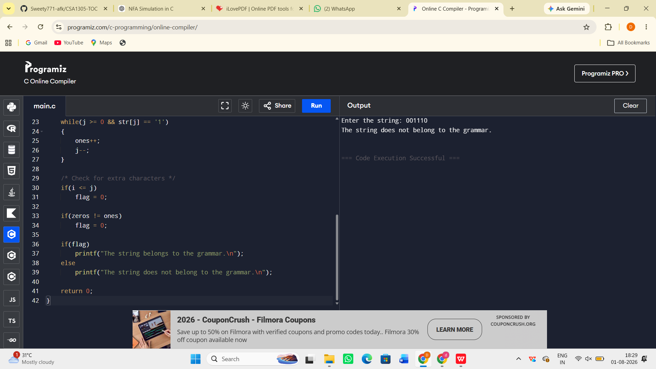

Result:
The C program to check whether a given string belongs to the Context Free Grammar S → 0S1 | ε was successfully implemented and executed. The program correctly accepts strings of the form 0ⁿ1ⁿ and rejects all other strings

